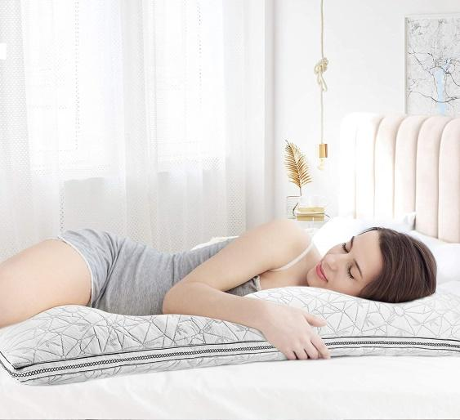
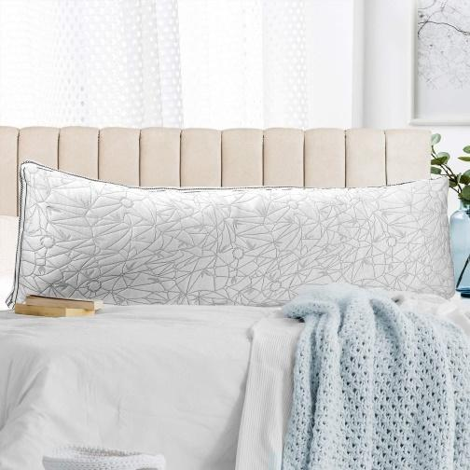

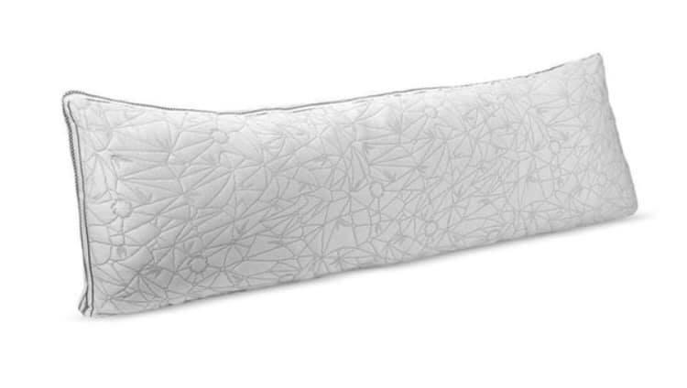
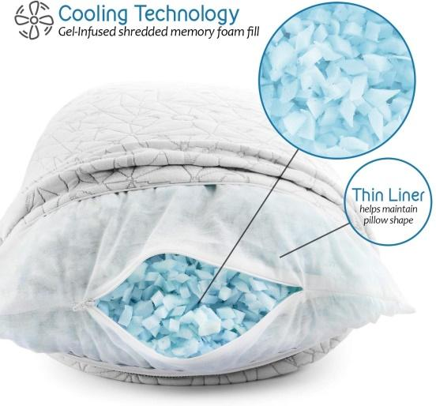
Clara Clark Body Pillow
- New Body Pillow $70
- Amazon and Wayfair sell for $66-$75 plus shipping
- Sized 20”x 54” which make this pillow 4 1/2 feet in length! It comes over stuffed and adjustable. Straddle while you sleep for perfect spine and hip alignment. Helps alleviate Back, Hip, Shoulder Pain and anxiety.

- This GEL INFUSED MEMORY FOAM PILLOW takes it to a whole new level! The removable cover is made of Velvet Bamboo that is supper soft and cozy to the touch for a breathable and comfy sleep. These hypoallergenic pillows are made with bamboo rayon. This material is antibacterial, dust mite resistant, and will minimize odors.

